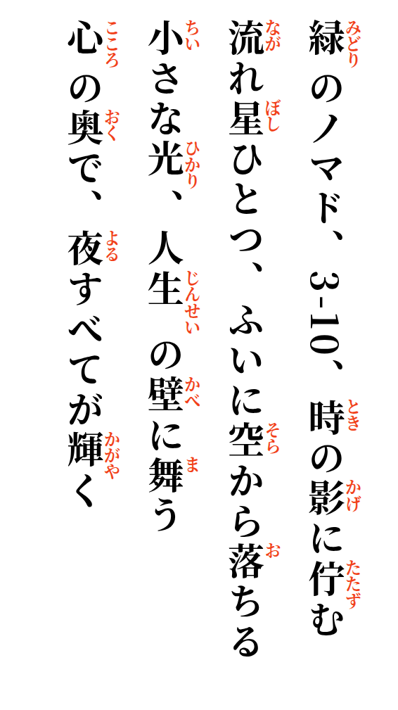
The green Nomade, 3-10, stands quietly in the shadow of time
One shooting star suddenly falls from the sky
Small lights dance upon the wall of life
Deep within my heart, the whole night shines

